# Project: Analyzing a Market Test

## Plan Your Analysis

1. **What is the performance metric you’ll use to evaluate the results of your test?**

The gross margin.

1. **What is the test period?**

|  |  |
| --- | --- |
| **Item** | **Period** |
| Historical Analysis | 52 weeks |
| Trend Analysis | 12 weeks |
| Testing | 12 weeks |
| **Total** | 76 weeks |

Data from 2015-02-06 to 2016-07-22 is required.

1. **At what level (day, week, month, etc.) should the data be aggregated?**

Week.

**The variables used to match control units to treatment units**:

* Trend
* Seasonality
* Square Feet
* Average Monthly Sales per store

## Match Treatment and Control Units

|  |  |  |
| --- | --- | --- |
| Treatment Store | Control Store 1 | Control Store 2 |
| 1664 | 2341 | 12019 |
| 1675 | 3235 | 1675 |
| 1696 | 2301 | 7334 |
| 1700 | 8717 | 1508 |
| 1712 | 7434 | 9017 |
| 2288 | 1807 | 8817 |
| 2293 | 7770 | 7811 |
| 2301 | 1863 | 1696 |
| 2322 | 7284 | 7584 |
| 2341 | 2383 | 3102 |

## Analysis and Writeup

Lift Analysis for Control vs Treatment for the Central Region.

|  |  |  |  |  |  |  |
| --- | --- | --- | --- | --- | --- | --- |
| **Lift Analysis for Sum_Gross Margin**   | Lift | Expected Impact | Significance Level | | --- | --- | --- | | 36.2% | 694 | 99.2% | |
| 4 **Summary Statistics for Sum_Gross Margin by Test Group**   | Statistic | Treatment | Control | | --- | --- | --- | | Average | 39.74 | 5.13 | | Minimum | 20.09 | -12.84 | | Maximum | 67.52 | 50.84 | | Standard Deviation | 17.15 | 17.47 | |  |

Lift Analysis for Control vs Treatment for the West Region.

|  |  |  |  |  |  |  |
| --- | --- | --- | --- | --- | --- | --- |
| **Lift Analysis for Sum_Gross Margin**   | Lift | Expected Impact | Significance Level | | --- | --- | --- | | 31.1% | 437 | 98.9% | |
| 4 **Summary Statistics for Sum_Gross Margin by Test Group**   | Statistic | Treatment | Control | | --- | --- | --- | | Average | 39.17 | 7.76 | | Minimum | 12.34 | -10.17 | | Maximum | 55.30 | 32.77 | | Standard Deviation | 16.34 | 11.94 | |  |

Lift Analysis for Control vs Treatment for the Combined Region:

|  |  |  |  |  |  |  |
| --- | --- | --- | --- | --- | --- | --- |
| **Lift Analysis for Sum_Gross Margin**   | Lift | Expected Impact | Significance Level | | --- | --- | --- | | 33.6% | 565 | 100.0% | |
| 4 **Summary Statistics for Sum_Gross Margin by Test Group** |  |

| Statistic | Treatment | Control |
| --- | --- | --- |
| Average | 39.45 | 6.44 |
| Minimum | 12.34 | -12.84 |
| Maximum | 67.52 | 50.84 |
| Standard Deviation | 16.30 | 14.63 |

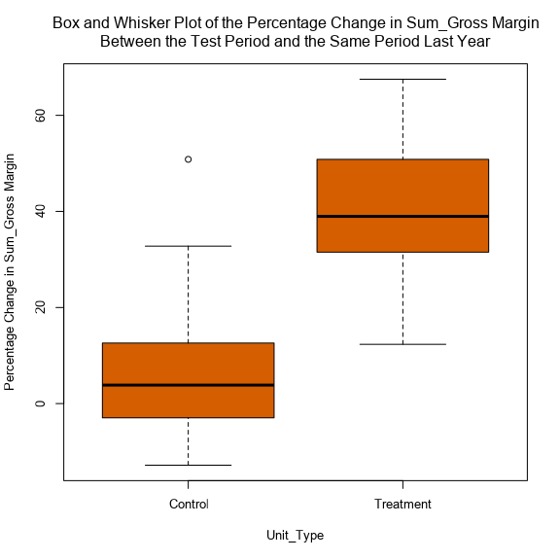

In conclusion, I would recommend Round Roasters implement the new menu to all stores due to a lift of 33.6% at a significance of 100%.

**Lift from the new menu for the West & Central Region.**

|  |  |  |
| --- | --- | --- |
| Region | Lift | Significance Level |
| West | 31.1% | 98.9% |
| Central | 36.2% | 99.2% |

**Lift from the new menu for the Combined Region (West & Central).**

|  |  |  |
| --- | --- | --- |
| Region | Lift | Significance Level |
| Combined (West & Central) | 33.6% | 100% |